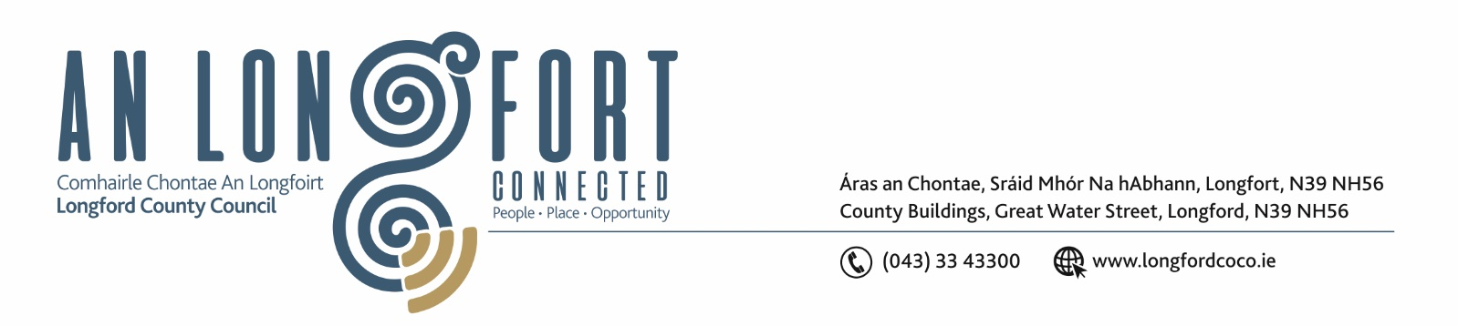

28th Feabhra 2019.

Chuig: Gach Ball don Chomhairle.

A Chomhairleoir,

Iarrtar ort bheith i láthair ag Cruinniú Feabhra/Marta Chomhairle Chontae Longfoirt a tionólfar i Seomra na Comhairle, Aras an Chontae, Longford ar an Chéadaoin, 6u Marta 2019 ag 4.00 p.m chun gnó a dhéanamh d’réir an Chláir thíos.

You are requested to attend the combined February/March Meeting of Longford County Council to be held in the Council Chamber, Aras an Chontae, Great Water Street, Longford on Wednesday, 6th March 2019 at 4.00 p.m. to transact business, as set out on the Agenda hereunder.

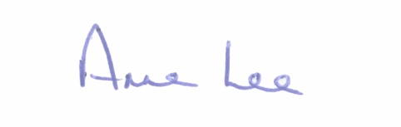
Mise le meas,

__________________
Anne Lee,
Meetings Administrator.

C L A R

- Confirmation of Minutes of the following meetings of Longford County Council -

- Special Meeting held on the 9th January 2019.
- Monthly Meeting held on the 16th January 2019.
- Copies enclosed.

- Matters arising from Minutes.

- To note Chief Executive Orders - enclosed.

4 . To note Monthly Management Report - to follow.

5. To note adopted Minutes of Corporate Policy Group Meeting held on
12th December 2018 - enclosed.

6. Economic and Community Development, Human Resources & Corporate Services,
Cultural & Recreational Services, Regeneration.

- To note adopted Minutes of Economic Development and Enterprise Strategic Policy
Committee Meetings held on the 17th September and 12th November 2018 – copies enclosed.

- Consideration and adoption of Amendment to the Business Incentive Scheme – enclosed.

- Consideration and adoption of the Draft Diaspora Strategy – enclosed.

- To note County of Longford Local Electoral Areas and Municipal Districts Order 2018 – enclosed.

- To note Director’s Report – Eastern & Midland Regional Assembly. Draft Regional Spatial and Economic Strategy 2019-2031 – report enclosed.

- National Community Weekend Event Fund 2019 – details enclosed.

- Notices of Motions submitted by Councillors, as listed hereunder –

Councillor Martin Mulleady.

"I propose that former US President, Bill Clinton, be invited to be the keynote speaker at the next Albert Reynolds Memorial Lecture."

7. Finance & Information Systems.

- To note Public Liability Claims received since January meeting of the Council.

- Consideration of Capital Budget 2019-2021 - to follow.

- Local Government Act 2001 - Annual Ethics Declaration.

- Consideration of disposal of Pot of land at Templemichael Glebe, Longford to John Halnon and Mary Cronin in accordance with the terms of Section 183 of the Local Government Act 2001 issued on the 18th February 2019.

- Notices of Motions submitted by Councillors, as listed hereunder –

Councillor Martin Mulleady.

"I propose that a letter of thanks and support be sent to the trustees of the Kevin Bell Repatriation Trust. Also, that Longford County Council make a contribution towards the fund in memory of all the families who sought help to get their loved ones home to Ireland for internment, especially the McGee family from Drumlish and the Murphy family from Ballinamuck who with the help of this fund were able be bring their sons, Danny and James, home.”

8. Planning, Housing, Infrastructure, Environment & Emergency Services.

- To note Planning Applications received since January meeting of the Council.

- (i) To note adopted Minutes of Housing Services Strategic Policy Committee held on the 4th December 2018 – copy enclosed.
(ii) To note adopted Minutes of Infrastructural and Environmental Strategic Policy Committee Meeting held on the 5th December 2018.

- Consideration and adoption of Waste Presentation Bye-Laws - enclosed.

- Consideration of following recommendation from the Infrastructure and Environment Strategic Policy Committee -

“That Longford County Council writes to Waterways Ireland requesting that in the event of Waterways Ireland lodging a planning application in the future for the reinstatement of the weir on the River Shannon at Cloondara/Termonbarry, that
consideration be given to including sluice gates into the design of the weir.”

- Consideration and adoption of Draft Policy on Decorative Paving and Re-instatement of Footpaths - enclosed.

- Notices of Motions, submitted by Councillors, as listed hereunder –

Councillor Mark Casey.

“In respect of the recent Board Na Mona application to Bord Pleanala, that this Council writes to the Minister to put in place a Moratoria on any decision until the new Wind Farm Guidelines are in place, which are due from the Minister’s office shortly.”
“That prior to any wind turbines being erected by Bord Na Mona, that this Council gets an independent noise survey done of the bogs where the proposed wind farms are being erected. Thus providing a base line for noise prior to the erection of the wind turbines.”

Councillor Gerard Farrell.

“I call on Longford County Council to write to An Bord Pleanala requesting that no permissions be given for wind turbines until the proposed new guidelines are issued by the Department of Housing, Planning & Local Government.”

9. Correspondence - circulated
(a) Letter dated 24th January 2019 received from Department of Health regarding CervicalCheck.
(b) Letter dated 31st January 2019 received from Department of Health regarding Medical Card Application process.
(c) Letter dated 31st January 2019 received from HSE regarding Child Phychologists posts.
(d) Letter dated 19th February 2019 received from Department of Housing, Planning and Local Government regarding criteria for the Rebuilding Ireland Home Loan.

10. Training –

Consideration of Report from Corporate Policy Group.

11. Votes of sympathy.



